**PASSPORT AUTOMATION SYSTEM**

USE CASE DIAGRAM:

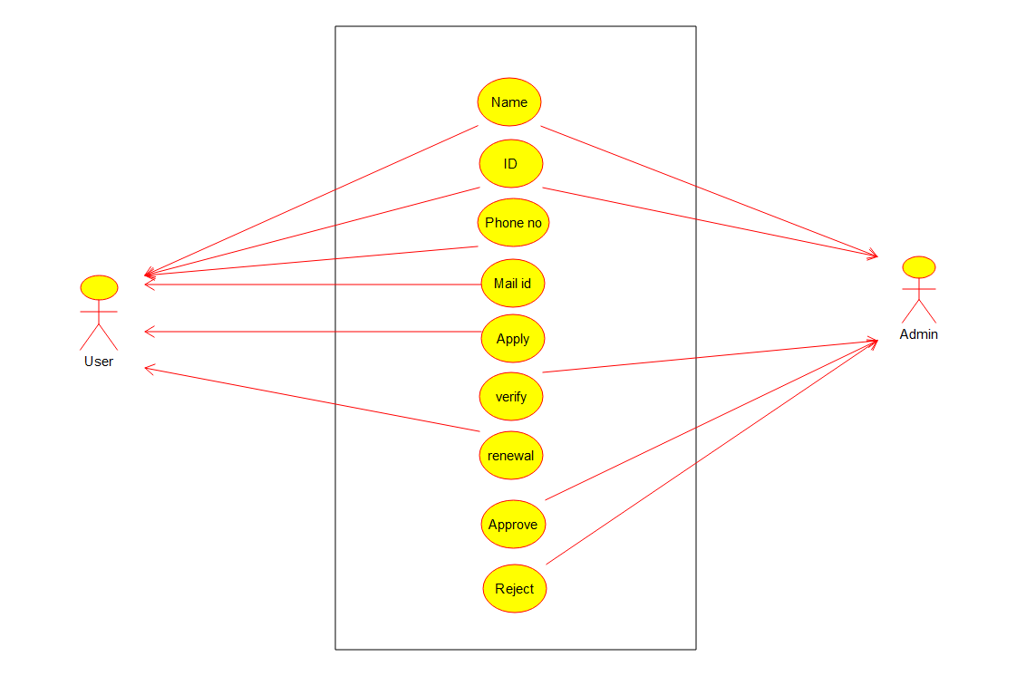

CLASS DIAGARM:

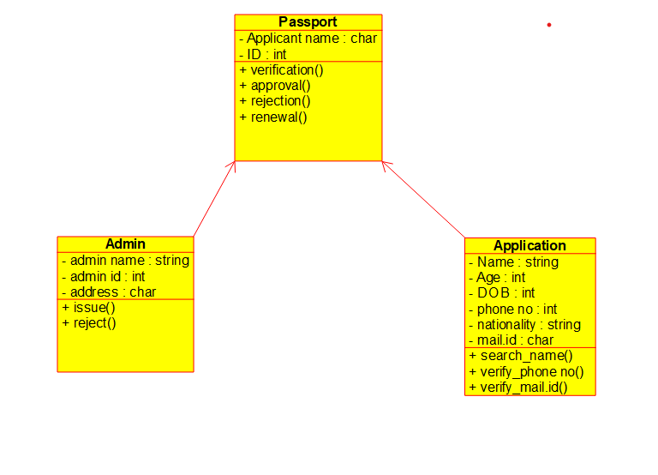

OBJECT DIAGRAM:

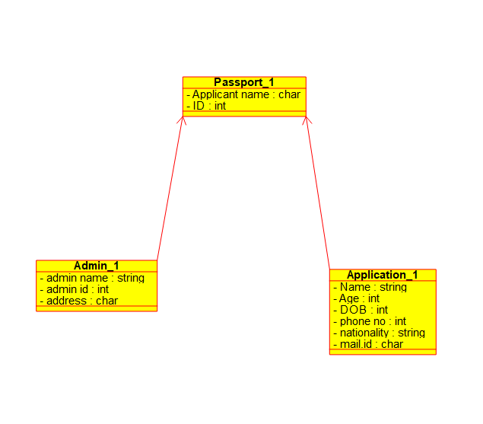

ACTIVITY DIAGRAM:

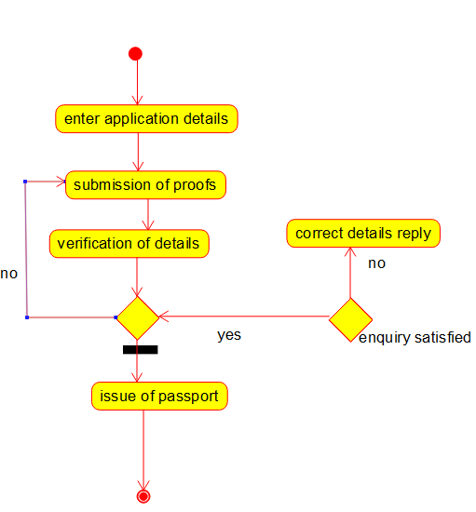

SEQUENCE DIAGRAM:

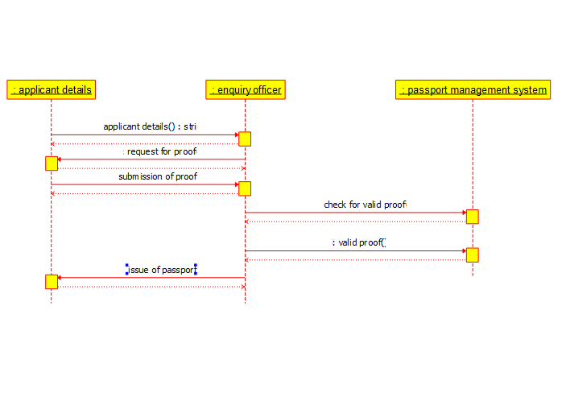

COLLABIRATION DIAGRAM:

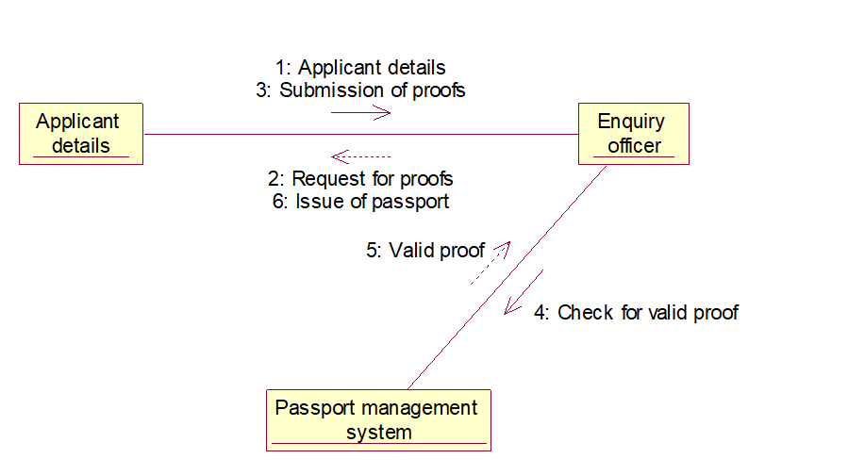

STATE CHART DIAGRAM:

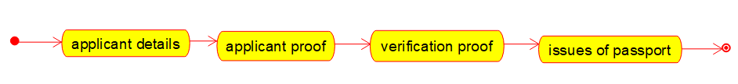

COMPONENT DIAGRAM:

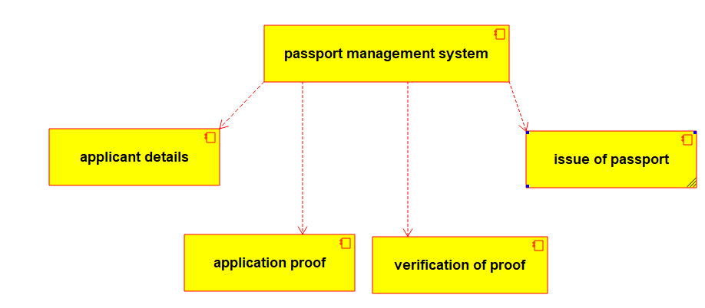

DEPLOYMENT DIAGRAM:

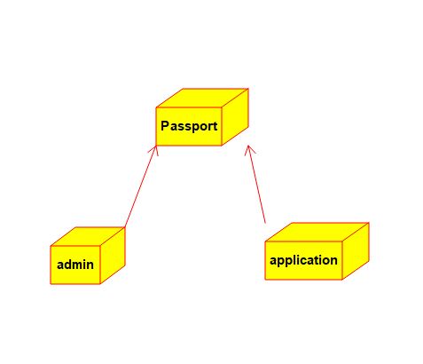

**PROGRAM CODING:**

**APPLICANT:**

Public class Applicant

{

Public Integer firstname;

Public Integer lastname;

Public void passport()

{

}

}

**PASSPORT APPLICATION SYSTEM:**

Public class passport application system

{

Public Integer details;

Public Integer proof;

Public class Applicant

{

Public Integer firstname;

Public Integer lastname;

Public void passport()

{

}

Public void verification()

{

}

Public void issue()

{

}

Public void cancel()

{

}

}

**OFFICER:**

Public class officer

{

Public Integer form;

Public Integer responsible;

Public void Database()

{

}

}